Berikut ini jawaban saya menganai topic wawasan hari ini.  
  
1. Perbedaan Spring dan Springboot ?

2. Kenapa harus Spring dan Springboot ?

3. Apa itu Aplication starter package pada Springboot ?

4. Bisakah kita mengubah web server pada springboot selain tomcat ?

5. Pom pada spring apakah tetap dipakai di springboot ?

6. Apa itu Yaml ?

7. Bagaimana cara melindungi paket daya yang kita akses dari application server, baik itu Rest dan yang lainnya yang berbau microservice ?

8. Apa saja strategi perlindungan data yang dikirim via microservice ?

9. Konon dikatakan Springboot lebih ringan, Benarkah ?, Apa saja yang membuatnya lebih ringan ?

10. Bisa dibandingkan dengan pengalaman misal, berapa kali create prject, ganti konfig, kalau pakai spring ? Nah kalau pakai springboot bagaimana kecepatan start nya ? Apakah benar less config dan less coding ?

11.Nah ini topik wawasan,  
Bagaimana perbandingan kinerja web apps yg dibangun dari nodejs, golang, spring/boot, php

1. Spring Boot is basically an extension of the Spring framework which eliminated the boilerplate configurations required for setting up a Spring application.  
   Spring Boot require only one dependency to get web application up and running.  
   That means, if you make an application in Springboot it requires lesser dependency than using Spring for making the same application.

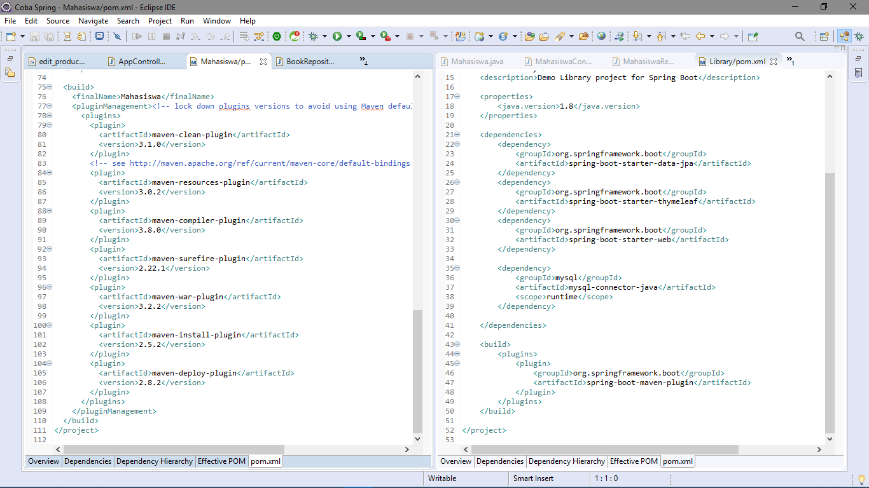  
  
on the left side is a Spring pom.xml file and on the right side is a Springboot pom.xml file, as you can see, I’m using lesser dependency on Springboot pom.xml.  
In Springboot It does not use XML configurations anymore and implements the convention over configuration principle.

2. Spring provides more flexibility over configuration than springboot, because Spring has so many configuration option to chose, we can make more structured application.  
Spring Boot aims to shorten the code length and provide you with the easiest way to develop a web application, Springboot privides autoconfiguration to helps create a stand-alone application with less or almost zero-configuration.

3. Is a package application to start a springboot application, we can generate them in start.spring.io, so I think it is basicly a starter project to start develop a springboot application.

4. yes you can, beside tomcat there is another web server like Jetty and Undetoy.  
why we commonly use tomcat beside the other two ?, it’s simply because tomcat is default embedded servlet container there is nothing you need to do to the default implementation to use Tomcat.  
but if you wanna switch to another web server, you need some configuration before you can use it.

5. yes, in springboot you can use pom to import a dependency like in spring

6. YAML is basicly an application.properties in springboot, but have some feature that application.properties, in YAML you didn’t use “=” but you can use “:” plut in YAML you can use nested declaration like in this example below.  
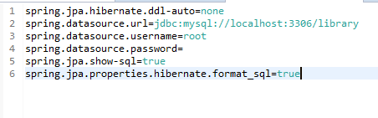

On the above is an application.properties for my MVC project.

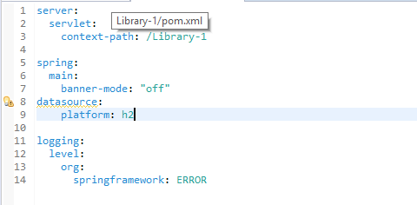  
and this is YAML, instead im declaring “server.servlert.context-path = /Library-1”, as you can see I’m using nested declaration using “:” and I think YAML is more convenient than application.properties.  
and YAML stand for Yet Another Markup Languages or YAML Ain’t Markup Languages.

7. from what i’ve been reading, we can use a JWT (Json Web Token) to protect data package

8. **AuthenticationServer** that returns a JWT token to use **Spring Security,** to secured our MicroServices so that the rest of the API can only be called with a valid JWT token.

9. Yes, Springboot is lightweigh because you don’t have to create so many object, Springboot help you creating those object.  
for example I don’t need to creat an object to execute some SQL querry, I just make a model class with @Entity Annotation then make a Service Class and give @Service and @Transactional to the class, then give @AutoWire annotation to wire Repository class so every setter and getter in Model clas is connected with Service class then declare a method to replace edit, delete, select and save in SQL.  
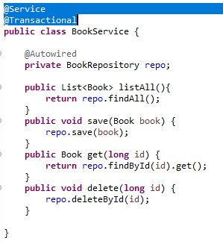

10. Yes with Springboot I can feel less configuration, because in Spring you nedd to configure those Dispacher Servlet by your self, but in Springboot you don’t need to do that, and I take lesser dependency to start, it helps me to download lesser library because I have poor internet connection.  
  
11. For my persona experience for developing web application with Code Igniter and Springboot.  
for developing process is easier with springboot because I don’t have to code SQL sintaks for making CRUD in web application, but in Code Igniter still using SQL sintaks.  
for deploying is php need to start Xampp application but in Springboot can lauch it trough tomcat that is already embed in Springboot.